April 12th – pick supervisor by now

May 12th - is when project proposal is due

**Assignment**

* Project proposal
* Literature Review - report

**Originality Ways to be original (Phillips, 1993):**

* carrying out empirical work that hasn’t been done before
* making a synthesis that hasn’t been made before
* using already known material but with a new interpretation
* taking a particular technique and applying it to a new area
* bringing new evidence to bear on an old issue
* being cross-disciplinary and using different methodologies
* looking at areas that people in the discipline haven’t looked at before.
* adding to knowledge in a way that hasn’t been done before.
* Mathematical equations

Audience for posters – showcase in INB atrium, replicates the settings of a conference.

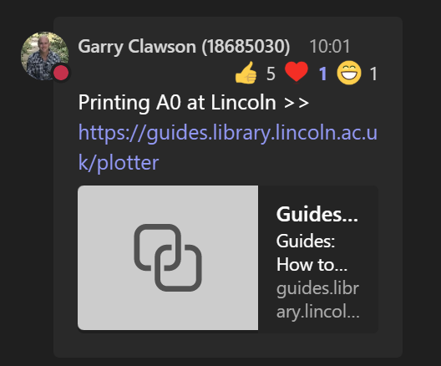

<https://guides.library.lincoln.ac.uk/plotter>

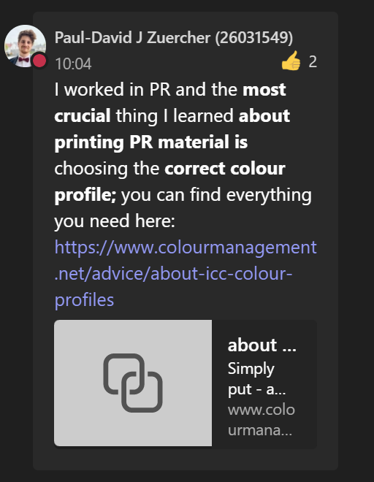

<https://www.colourmanagement.net/advice/about-icc-colour-profiles>

Research at Lincoln:

<https://www.lincoln.ac.uk/socs/research/>